Soothing a Crying Baby

Having a new baby can be a wonderful time, but it can also be challenging. Babies cry, sometimes a lot. The period of time when babies cry most is 2-4 months of age.

The crying won’t last forever!

Check the easy things first.
Be sure your baby has been fed, burped, changed,
and is dressed for the weather.

___________________________________________________________________________________________________________

Is your baby hungry?
If baby becomes too hungry they can become extremely fussy and can be difficult to calm and feed.
Learn early hunger signs:
- Opening and closing mouth.
- Sucking or moving hands to mouth.
- Rooting (baby is searching for food and moving head or opening mouth).
Does your baby need to burp?
Babies swallow air when they breastfeed or suck from a bottle. If the air isn't released, it may cause some pain.

How to burp baby:
- Hold baby against your chest with his or her chin resting on your shoulder. Gently rub or pat the back.
- Place baby on your lap, supporting his or her chest with one hand and using your other hand to gently rub or pat the back.

Is your baby not feeling well?
- Check your baby’s temperature to rule out a fever.
- If your baby's crying "just doesn't sound right," or if you think your baby might be sick, trust your instincts and call your doctor.

Is your baby’s tummy upset?

Gas, colic, or allergies can cause stomach pain.
- Apply pressure by lightly placing your hand on baby’s belly or gently move his or her legs in a bicycle motion to relieve pain.
- If you think it has something to do with what your baby eats, check with your doctor.

Does your baby have a dirty diaper?

Some babies let you know right away when they need to be changed.
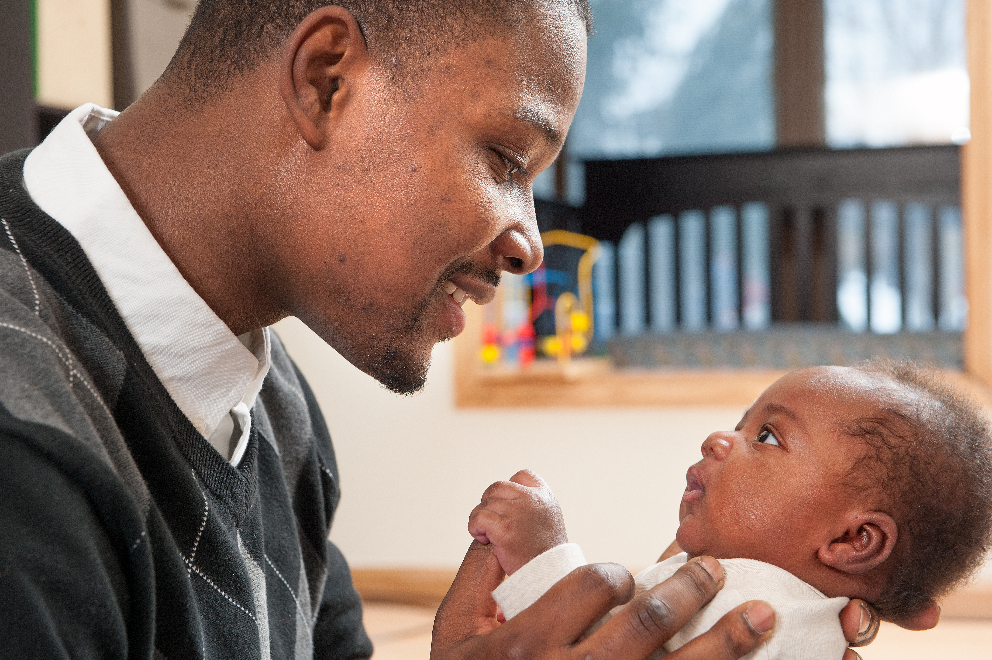

Is your baby sleepy?

Instead of nodding off, some babies may fuss and cry, especially if they are overly tired. Learn early sleepy signs.

    - Rubbing eyes and/or ears.
    - Yawning.
    - Closing fists.
    - Making fast jerky movements.

Does your baby want to be held?

Babies need a lot of cuddling!
- Skin-to-skin contact lowers baby’s and parent’s stress level.
- Skin-to-skin contact is when baby is wearing just a diaper and placed on mom or dad’s bare chest.
- Always make sure you are awake and alert when practicing skin-to-skin.

Are people smoking around your baby?
Never let anyone smoke around your baby.
- Babies exposed to smoke can be more colicky.
- Smoke outside or quit.
- Call (800) QUIT-NOW for help.

Is your baby too hot or too cold?

What other things can be tried to soothe your baby?
- Sucking can help to calm your baby. Offer your breast, a pacifier or your finger to suck.
- Swaddling:
- Use a sleep sack with swaddling attachments.
- Do not swaddle after baby shows signs that they are attempting to roll.
- Always place a swaddled infant to sleep on his or her back, in a crib, bassinet or pack and play and follow all safe sleep guidelines.
- Play music, sing a lullaby or try white noise.
- Get some fresh air.
- Rock baby in your arms or in a chair – put baby in crib when you feel sleepy.
- Talk softly and sweetly to baby.
- Stroke baby’s cheek or gently pat baby’s back.
- Give baby a warm bath, but check the temperature and provide close supervision.
- Try holding baby skin-to skin.
- Always keep baby close to you by placing the bassinet or pack and play in your room, near your bed – that way you can soothe quickly when needed.

- Baby should be dressed in the same amount of clothes as you.
- Remove extra clothing.
- Signs that your baby might be too warm include:
- Damp hair, sweaty back or chest, red ears or face.

Is your baby teething?
- On average, the first tooth breaks through between 4 and 7 months.
- Provide a cool cloth or cold teether for baby to suck.

Is your baby over stimulated or under stimulated?

- Crying can be a baby's way of saying, "I've had enough."
- Remove baby from loud noises or bright lights.
- Crying can also mean “I’m bored.”
- Change your baby’s environment.
- Listen to music, dance, or go for a walk.

Are there other things going on with baby?
- Babies can be troubled by something as hard to spot as a hair wrapped tightly around a tiny toe or finger.
- Some babies are extra-sensitive to things like scratchy clothing tags, fabrics or how they are held.

How to cope with your crying baby:
- Share baby care with your partner.
- Have a friend or relative take over for you once in a while so you can take a walk or a refreshing shower.
- If you become angry or frustrated with your baby, take a deep breath and gently lay him on his back in his crib.
- Check out additional resources on the Period of Purple Crying website at www.purplecrying.info.
- To learn more about how babies can sleep safely, visit www.michigan.gov/safesleep.
\

