Festivals

Harbor Beach
Halloween Weekend – North Park Campground
- 1st
- 1 – 3 pm: crafts
- 1 – 5 pm: hay rides
- 1 – 5 pm: Conservation Club
- 1 – 5 pm: fire department exhibit
- 4:30 pm: pumpkin judging
- 5 pm: costume judging
- 5:30 pm: costume parade
- 6 – 7 pm: trick or treating
- 7 – 10 pm: DJ in the park
- 8th
- 1 – 3 pm: crafts
- 1 – 5 pm: hay rides
- 1 – 5 pm: Conservation Club
- 1 – 5 pm: fire department exhibit
- 4:30 pm: pumpkin judging
- 5 pm: costume judging
- 5:30 pm: costume parade
- 6 – 7 pm: trick or treating
- 7 – 10 pm: DJ in the park
www.harborbeach.com

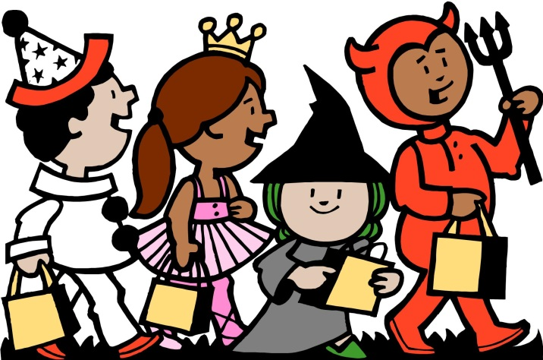

Pigeon
Fall Harvest Celebration
- 14th
Halloween Trunk or Treat
- 31st: 6:30 – 7:30 pm
- Winsor Fire Department parking lot
www.pigeonchamber.com

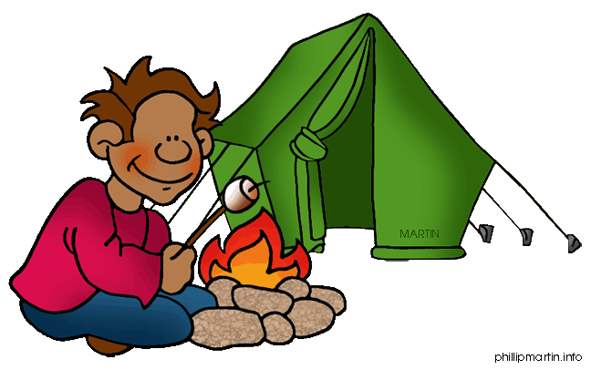

Sebewaing
Fall Family Fun Days – Bay Shore Camp
- 7th
- free camping
- 5 – 7 pm: mini golf
- 7:30 – 9 pm: arrow/laser tag
- 7:30 – 9 pm: glow mini golf
- 7:30 – 9 pm: community campfire
- 8th
- free camping
- 9 am: cider & donuts
- 10 am – 2 pm: inflatables
- 10 am – 3:30 pm: barrel train
- 10 am – 4 pm: camp tours
- 10 am – 7 pm: mini golf
- 10:30 am: pumpkin painting
- 10:30 am – 3:30 pm: scavenger hunt hayrides
- 11:30 am: free lunch
- 2 – 4 pm: zipline
- 6 – 8 pm: arrow/laser tag
www.harborbeach.com

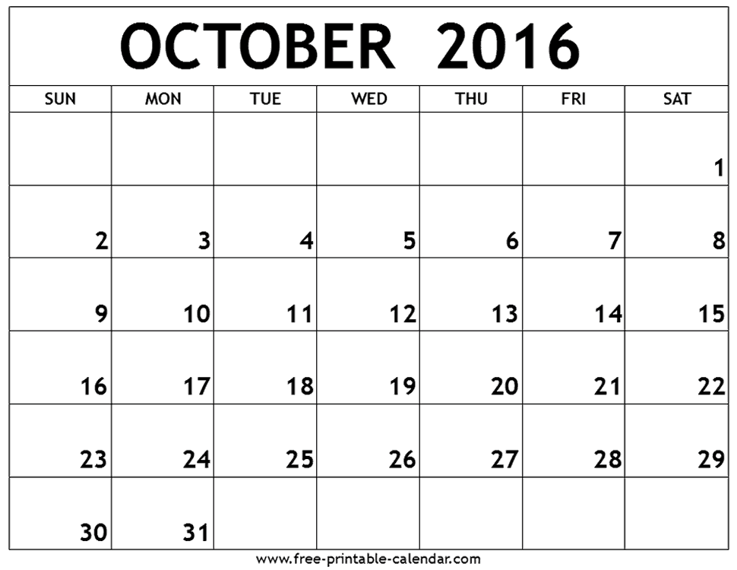
Huron County Nature Center

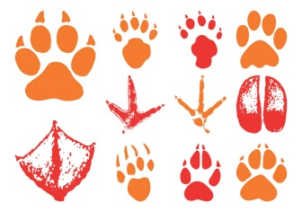

*Trails open 365 days a year from dawn til dusk.*

Farmer’s Markets
Harbor Beach
- 7th
- 2 – 7 pm
Pigeon
- 7th, 14th, 21st, & 28th
- 9 am – 4 pm
Port Austin
- 1st, 8th, & 15th
- 9 am – 1 pm

Library Activities & Events
Pigeon District Library
- Lap Sit Story Time – Tuesdays at 10 am
- Preschool Story Time – Tuesdays at 10:30 am
- Junior Jive – Fridays at 10 am

Playgroup
- Bad Axe District Library
- 10:30 am – 12 pm
- For more information, contact Yvonne at (989) 269.3493

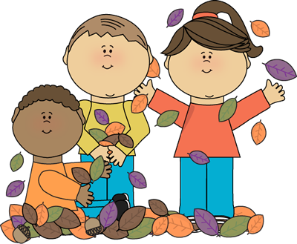

Let’s Talk…Parent to Parent
- Huron County Health Department
- For more information and to register, contact (989) 269.9721, ext. 152
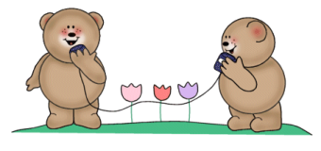

Neighboring County Events
Caro – Pumpkin Festival
- 6th – 9th

