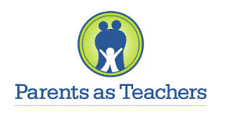
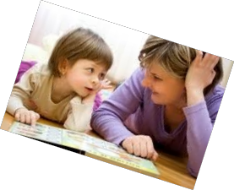

Our Vision:
All children will
grow and develop
to reach their full potential

PAT focuses on:

- Parent-child Interactions

- Development-centered Parenting

- Family well-being

Through Parents as Teachers, you will partner with a parent educator focused on your child’s healthy growth and development. Your parent educator will personalize information to fit with your family’s needs, concerns and hopes. Together, we will discuss goals for you as a parent and for your child. You will build on your strengths and skills.

Parents as Teachers Program includes:

Home Visits – Home visits are scheduled around times that are convenient for you and your family. Services can be weekly, bi-weekly, or monthly, depending on your family’s needs. Home visits are a time for the family to play and learn together!

Parent Connections – These are activities and workshops for parents where you can learn new ideas, have fun with your kids, and meet other parents!

Screenings and Referrals – Your home visitor will screen your child to ensure that he/she is on track developmentally. If your child has a delay or other concern, a referral can be made to have further assessments.

To enroll your child in the Parents as Teachers Program, please call Shelly Grifka at 989-269-3492.

